**Adjustable Current Source and Current Sink**

# 

# Introduction

This device can deliver a constant current. The constant current can be set to a certain value. The adjustable current source and current sink offers the following functions:

* Source an adjustable constant current varying from 0 to 1000 mA
* Sink an adjustable constant current varying from 0 to 1000 mA
* Set a timer for sourcing or sinking the set current
* Calculate the capacity when sinking a current from a connected load
* Automatically switch off if no current is flowing
* Calibrate the device

An SSD1306 display is used for the user interaction, together with three buttons to control the device. Additional feedback is given by a red LED and a green LED. This device has a built-in Ampere meter but this is not mandatory for its operation.

# Menu’s and control

The device uses four menu’s with various menu items for operation. Selection is done using the three buttons on the right which have the following functionality:

* Red = UP
* Blue = DOWN
* White = ENTER

A selected menu item is shown as inverted text on the display, which means it has focus. With the UP button and DOWN button, the next or previous menu item can be selected, giving that menu item focus. When the ENTER button is then pressed the selected menu item will be activated. If the selection is on a menu item that has a value, the value is shown as inverted after the ENTER button is pressed, giving it focus, after which the value can be changed using the UP button or DOWN button. Pressing the ENTER button again, returns the focus back to the selected menu item.

The following menu’s are available.

1. Main Menu
2. Current Source Menu
3. Current Sink Menu
4. Calibration Menu

The various menus and their menu items will be explained in the following sections.

### Main menu

This menu has the following menu items:

Current Source Menu

Current Sink Menu

Calibration Menu

With the UP button or DOWN button the previous or next menu item can be selected. Selecting one of the menu items with the ENTER button will activate the selected menu.

## Current Source Menu

This menu has the following menu items:

Current (mA):

Timer (hours):

START

Return to Main Menu

The set current is shown in mA and can be set between 0 and 1000 mA. The default Timer value is zero which means that no timer is set. The timer can be set between 0 and 24 hours. After having set the values, selecting the START menu item, followed by the ENTER button will start the current source. The red LED will be turned on. All settings are stored in non-volatile memory.

Note that when START is activated, this text changes to STARTED and the text ‘Return to Main Menu’ text changes to ‘<Press ENTER to stop>’, which is shown as inverted text to give it focus. Pressing the ENTER button will stop the current source. The current source will also stop when the timer has expired or if the load is disconnected. For the later, see the auto-off functionality.

## Current Sink Menu

This menu looks the same as the current source menu and behaves the same. When START is activated the blue LED will be turned on. You will also hear that the relays are activated as to be able to draw current from the connected load.

Note that all settings for current source and current sink, including the timer, are independent of each other and are separately stored in non-volatile memory.

## Calibration Menu

This menu is used to calibrate the device, which needs to be done once. Due to tolerances in some components the device needs to be calibrated. For this it uses the maximum current of 1 Ampere. For calibration the plugs that are used to connect the load, need to be short circuit.

This menu has the following menu items:

Current (1A):

Return to Main Menu

When the first menu item is selected and the ENTER button is pressed – and the connection for the load is a short circuit – a current of 1 Ampere should flow. If this is not the case, the current can be adjusted by the UP button and DOWN button. After the current is set correctly to 1 Ampere, the ENTER button must be pressed again. During calibration the value of the ADC is shown on the screen. The maximum ADC value is 1023 but will be slightly below that value with a current of 1 Ampere.

Note that by making the short circuit for calibration, the transistor of the device needs to dissipate a lot of heat. Make sure to keep the calibration cycle short and remove the short circuit when calibration is done.

The calibration value is stored in non-volatile memory.

## Timer and capacity calculation

The timer functionality can for example be used for charging an NiMH battery. In order to fully charge an empty NiMH battery it needs to be charged with 1/10 of its capacity for 14 hours.

When the timer is set when the current sink mode is activated, the device will keep track of the capacity that is drawn from the load, expressed in mAh. With this feature, the device can be used to measure the capacity of a fully charged NiMH battery by discharging the battery until it is empty (auto-off feature). This information will then be shown at the end of in the main menu after discharging is done. The main menu will then looks as follows:

Current Source Menu

Current Sink Menu

Calibration Menu

Capacity (mAh):

## Auto-off

The device has an auto-off feature which is activated when the current source cannot supply the set current which is the case when no load is connected. In case of a current sink, the auto-off is activated when the set current cannot be drawn from the load. The latter can be handy in case of discharging an NiMH battery so that current sinking stops when the battery is almost – but not completely – empty.

Note that the auto-off functionality only works when currents of more than 50 mA are used.

# Hardware

## Schematic diagram

The schematic diagram shows the hardware of this device. As can be seen, an Ampere meter was integrated. This is not mandatory. For calibration you can use an external Ampere Meter. It is important to connect transistor BD137 to a heat sink.

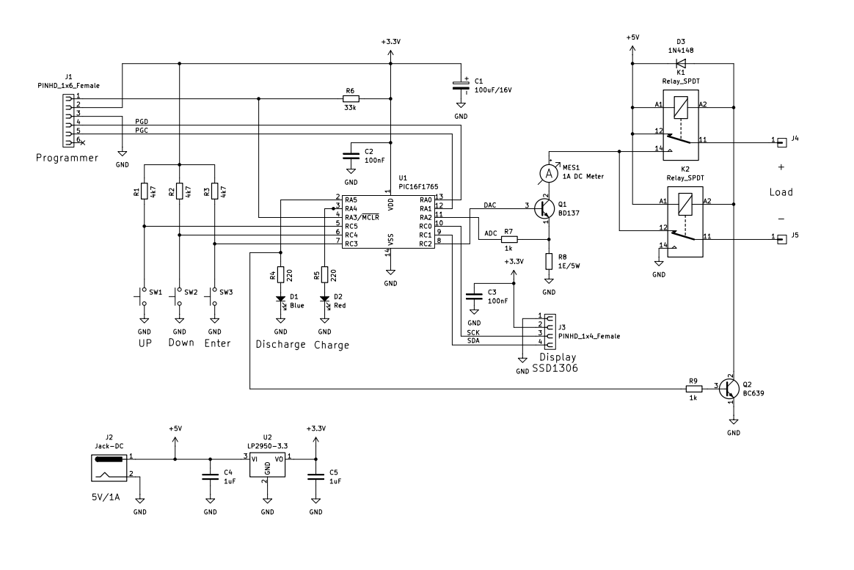

The device is powered by an external DC power supply of 5 Volt. This power supply must be capable of supplying a current of 1 Ampere. The connection for the programmer is not needed.

## Operation

When the user has set a current with the UP, DOWN and ENTER keys and the current source feature is activated, the PIC Microcontroller will use its on-board Digital to Analog Converter (DAC) to control the voltage on the base of transistor BD137, which acts as an emitter follower. At the same time the PIC Microcontroller will measure the voltage over the 1 Ohm power resistor using its on-board Analog to Digital Converter (ADC). As long as the current through the resistor is below the current set by the user, the voltage on the base of the BD137 will increase. In the meantime the red LED will be turned on. The relays are not activated which means that the current goes through the load that is connected.

When the current sink mode is selected, the operation is almost the same except that now the blue LED will be turned on and the relays will be activated by transistor BC639. In this mode the current is drawn from the load.

Note that for the current source, the 5 Volt supply voltage is used. When the connected load is using a high voltage, the 5 Volt supply voltage may not be sufficient. In that case the relays should be connected to a higher voltage.

# Appendix: Pictures of the hardware

The following pictures show how the device was built. The electronics is split over two boards, one board containing the display and the Microcontroller and another board containing the transistors, the 1 Ohm power resistor and the relays. The split was made to fit the electronics in the used cabinet.

## Front panel

### Front side with the display

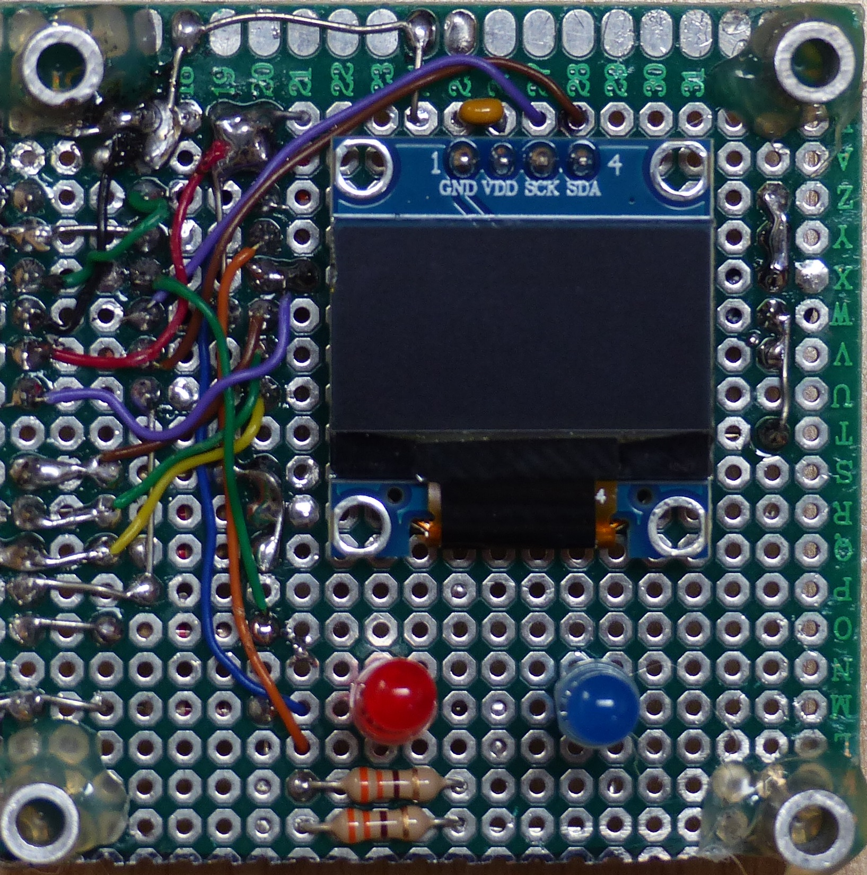

### Back side with the Microcontroller

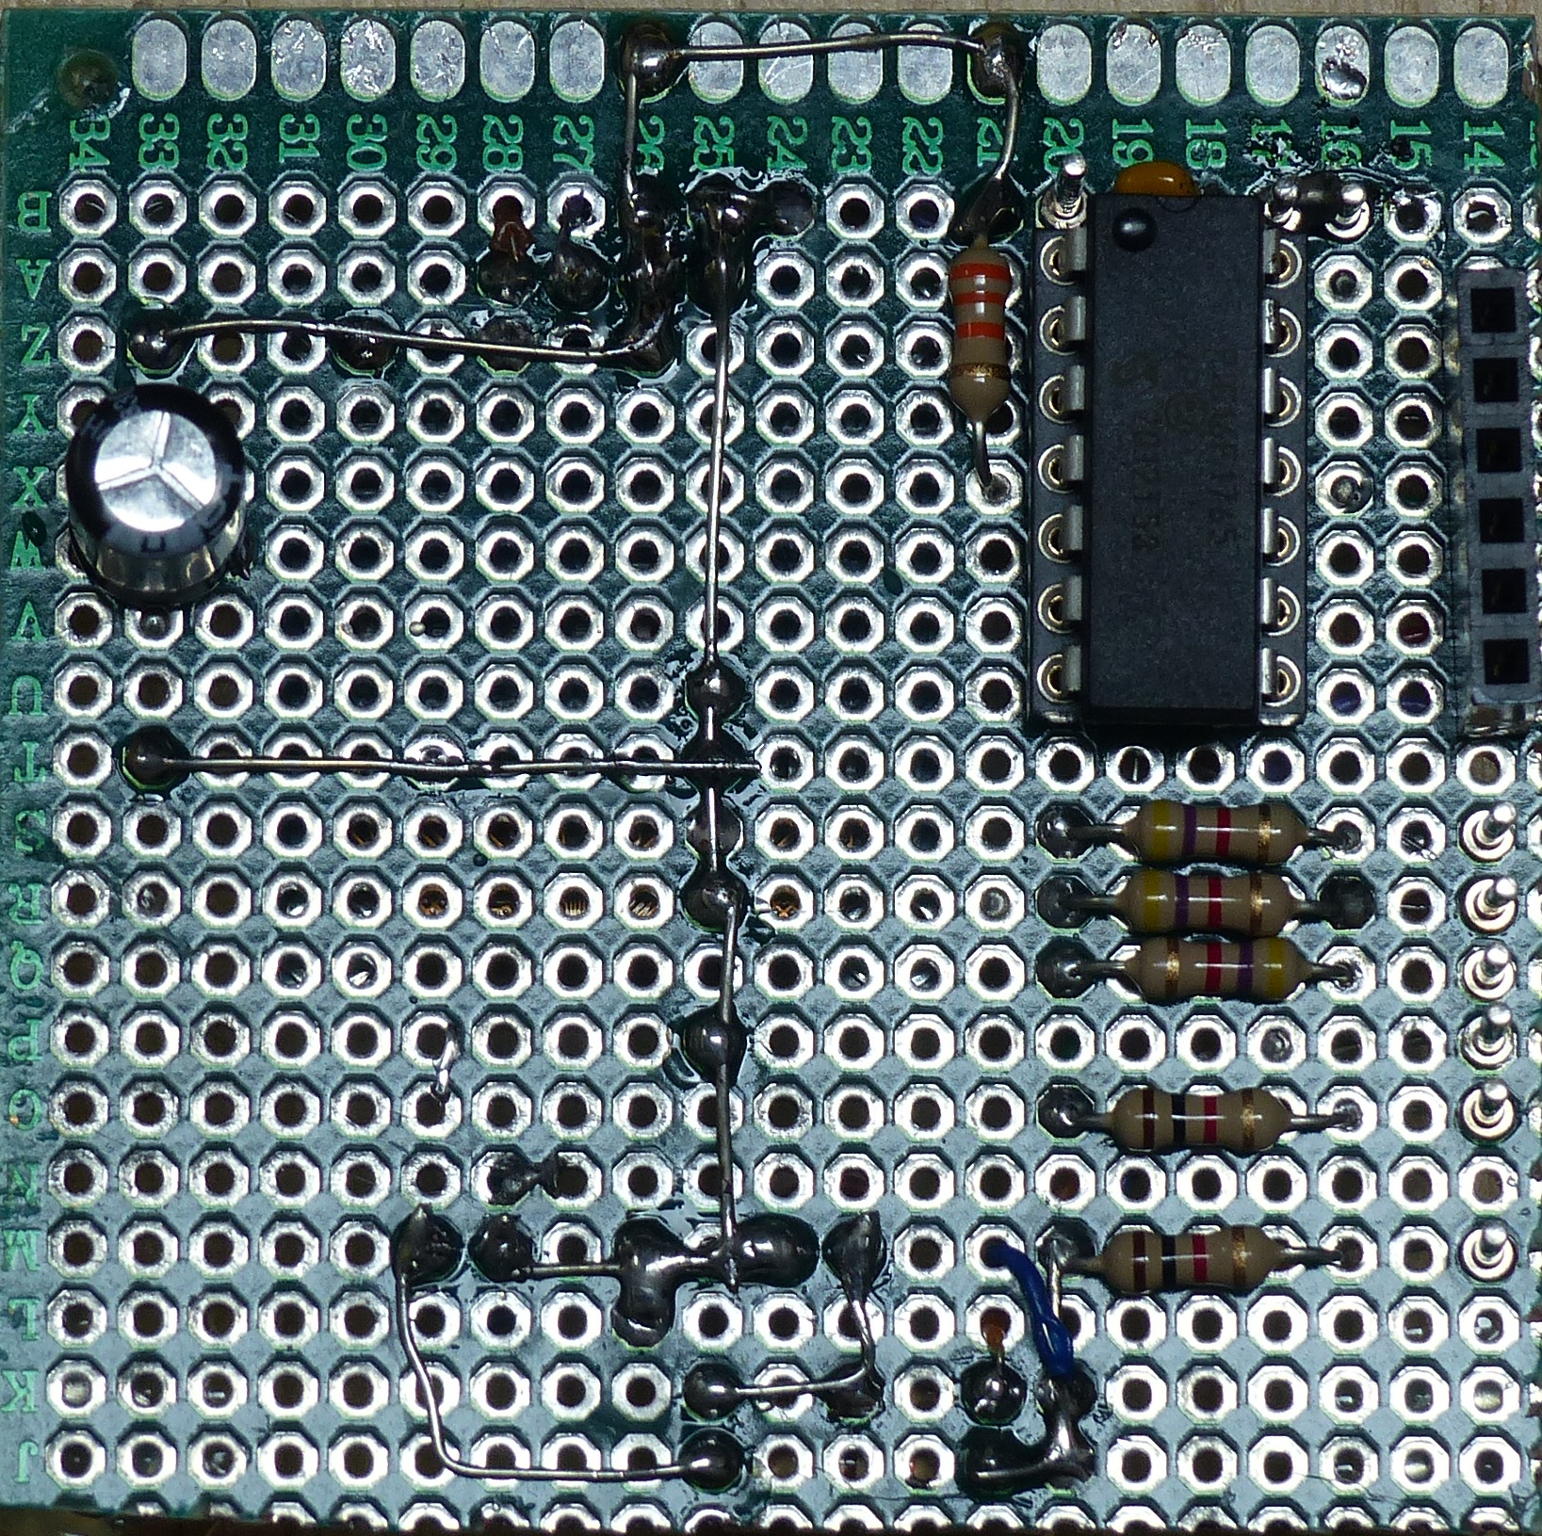

## Bottom panel

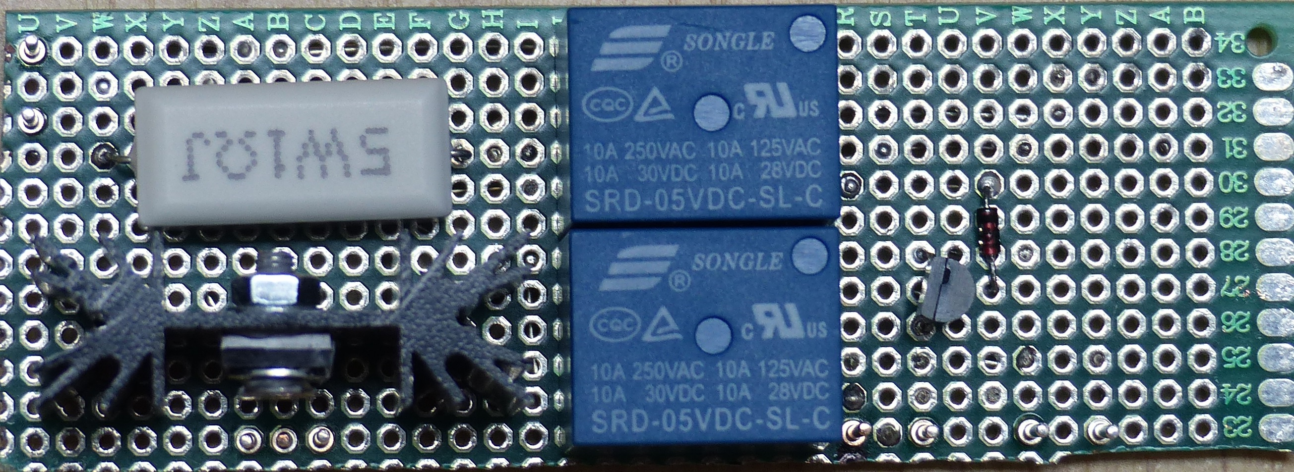

## Back of cabinet

